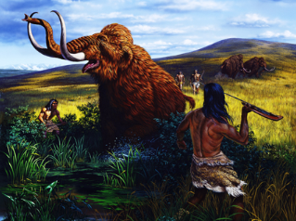
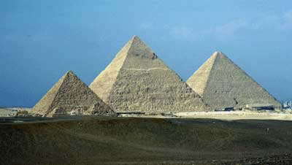

Anthropology 23: World Prehistory

Instructor: Dr. Jelmer Eerkens
Contacts: 752-1348 (office), jweerkens@ucdavis.edu
Office: 306 Young Hall

Synopsis: Anthropology 23 examines our collective human prehistory, from approximately 500,000 years ago to the most recent past. The course is focused on several key developments in human societies including the transition out of the last ice age, the domestication of plants and animals, the establishment of “complex societies,” and the development of important technologies, such as pottery and writing. Because of the sheer breadth of the subject matter, we will not focus on any early society in great detail, but will sample from a range of ancient cultures from around the world.

Your Grade is based on:
- Two Map Quizzes
- Two Short Writing Assignments
- Midterm Exam
- Final Exam

Examinations: Will cover lectures, readings, and any films shown in class. You are responsible for all materials. Exams will consist of multiple choice, short answer, and short essay questions. If you miss any exam you must present a valid (written) excuse.

